Cyber Security

Class no 07

28 Sep 2024

CIA 🡪 Fundamental concept

C – Confidentiality

I – Integrity

A – Accessibility

Defensive Security: Protect any system

Offensive Security: Testing security 🡪

* Penetration Testing(Ethical Hacking) : find any security gap
  + Information Gathering 🡪 BLACK BOX,WHITE BOX, Gray BOX
  + Network Scanning 🡪
    - Scanning IP address
    - Details scanning for one IP address
    - Find the open port for target IP address (0 to 65535 port)
    - Probe packet(without data packet): find response to become ensure port is open or not
    - Scanning tools:
      * Nmap/ zenmap
      * Hhping2/hpings
      * Masscan
    - Need to know 6 topic
* Red Teaming: advance and un-analogue testing.

Discovery Scan

* Nmap –sn –PR (target ip)
* 192.168.10.0/24
* From Terminal nmap –sn 192.168.10.0/24
* Find live ip : nmap –sn 192.168.10.0/24 🡪C block
* 17 hosts up mean 17 hosts are in live

┌──(root㉿kali)-[~]

└─# **nmap -sn 192.168.0.101/24**

Starting Nmap 7.94SVN ( https://nmap.org ) at 2024-10-04 13:32 EDT

Nmap scan report for 192.168.0.1

Host is up (0.0076s latency).

MAC Address: D8:32:14:63:32:E8 (Tenda Technology,Ltd.Dongguan branch)

Nmap scan report for 192.168.0.108

Host is up (0.00075s latency).

MAC Address: A8:41:F4:1D:81:D1 (Unknown)

Nmap scan report for 192.168.0.101

Host is up.

Nmap done: 256 IP addresses (3 hosts up) scanned in 2.13 seconds

Common scanning Techniques

* Metasploitable -2
* nmap –sT 192.168.10.100 (only 1000 port work) 🡪 It is the default TCP scan method. It completes the three-way handshake, making it easier to detect by firewalls.

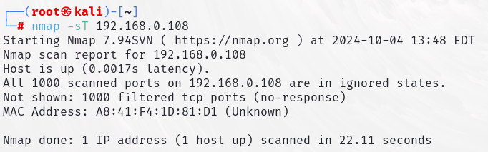

* nmap –sT 192.168.10.100 –p 80 🡪for single port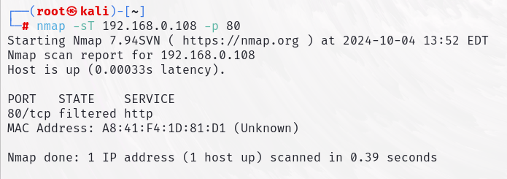
* nmap –sT 192.168.10.100 –p 80,44,123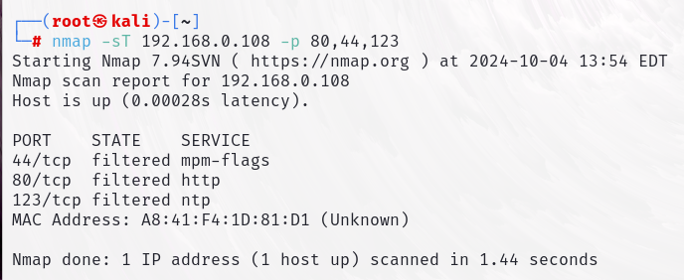
* nmap –sT 192.168.10.100 –p 80-1000
* nmap –sT 192.168.10.100 –p- 🡪for scanning all port (65535 port)
* nmap –sU 192.168.10.100 –p 80 🡪 for scanning UDP port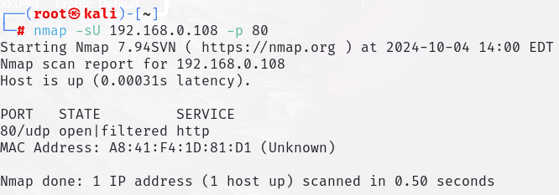
* nmap –sS 192.168.10.100 –p 80 🡪 syn port 🡪 just check port is open or not,not send data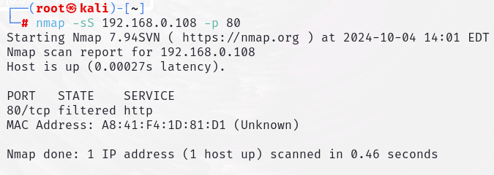
* open wireshark and run all above code in terminal
* nmap 192.168.10.100 –p 80 –sv 🡪 show service version (is it latest or old version)
* nmap 192.168.10.100 –p 80 –sv -O 🡪 for show operating system details

Nmap Scan Speed

* -T0-T5 (slow to fast search T1-T2..-T5)
* Normally use T4
* nmap 192.168.10.100 –p 80 –sv -T4

Inverse Scan (For bypass firewall)

* First send reset (allow firewall)
* If port in open, there was no any response and vice versa
* Download : Metasploitable-3 (Windows 2008)
* ping 192.168.10.100
* If ttl value 64,63 this is linux
* If ttl value 128,127 this is windows
* nmap 192.168.10.198 (showing blocking our ping probes)
* 2 technique for bypass
  + –sX –xmass
  + –sX –Maimon scan
* nmap 192.168.10.198 –sX –p 137,139,445 (if ip not work,create new ip on virtual box)

Scan Domain(when admin block any ip)

* nmap 192.168.10.100 –D RND:10 (open wireshark)

Enumeration (collect more details of target ip):

* SMTP Enumeration
  + 25 port is open (email gateway)
  + nmap –p 25 192.168.10.100
  + telnet 192.168.10.100 25
  + VRFY root (smpt command)
  + VRFY test
  + Hunter.io (collect mail ip service)
  + quit for exit
  + nano users.txt 🡪ctrl+X🡪y🡪enter
  + cat users.txt 🡪 show data
  + smtp-user-enum –M VRFY –U users.txt –t 192.168.10.100 (M = mode U=user t=target)
  + namp –p 2049 192.168.10.100 (p=port)
  + showmount –e 192.168.10.100

Target – 192.168.10.100 🡪 ping 192.168.10.100

If ttl value 64, 63 this is Linux

If ttl value 128, 127 this is windows

For find help menu 🡪 name –help example: namp –help

sudo passwd root🡪 change root password

su root 🡪 for switch to root

Process of Scan IP:

* Information Gathering
* Network Scanning
* Enumeration